THE TITLE GOES WITH EACH INITIAL LETTER CAPITALIZED

(PAPER TITLE, TIMES NEW ROMAN, 14 FONT SIZE, BOLD, ALL CAPS, CENTERED)

Author’s Name and Surname¹, Author’sName and Surname² (Paper author, Times New Roman, 10font size)
¹Author Affiliation, E-mail, Times New Roman, Italic, 10 font size
²Author Affiliation, E-mail, Times New Roman, Italic, 10 font size

Abstract.Use this document template if you are using Microsoft Word. Each paper must include an abstract. Begin the abstract with the word “Abstract” followed by a period in bold font, and then continue with a normal 11 point Times New Roman font.Abstract should be written in 200 words or less and with 10 font size, Times New Roman, justified, single line spacing. The objectives, methods and findings should be summarized in this section.

Keywords:component, formatting, style, styling, insert (Keywords should contain maximum 5 words that are written with 10 font size and separated with commas).

1. INTRODUCTION (HEADING 1,11 Font Size, bold, all caps)

It is expected that authors will submit carefully written and proofread material of the full paper.Spelling and grammatical errors, as well as language usage problems, are not acceptable in the final submission. The text should be formattedin Times New Roman, 11 font size, justified, single line spacing and can contain figures, tables, formulations. Page format should be A4 page size with margins 2.5 cm wide from the right, left, top and bottom. Full papers should be minimum 4 pages, and not exceed 5 pages including the references and pages should not be numbered.Papers should clearly describe the background of the subject, the authors work, including the methods used, and concluding discussion on the importance of the work. Papers are to be prepared in English. Technical terms should be explained. Acronyms should be written out at their first appearance.

2. MATERIALS AND METHODS(HEADING 1, 11 Font Size, bold, all caps)

All materials and methods that have been used in the work must be clearly stated and described in sufficient details or with references.

3. RESULTS AND DISCUSSION(HEADING 1, 11 Font Size, bold, all caps)

The results of the work should be explicitly described and illustrated. Supporting figures, tables and images of the resultsmay be included in the full paper. Figures, tables, and equations must be inserted in the text and may not be grouped at the end of the paper. Important: A miscount of figures, tables, or equations may result from revisions. Please double check the numbering of these elements before you submit your paper to your proceedings editor.

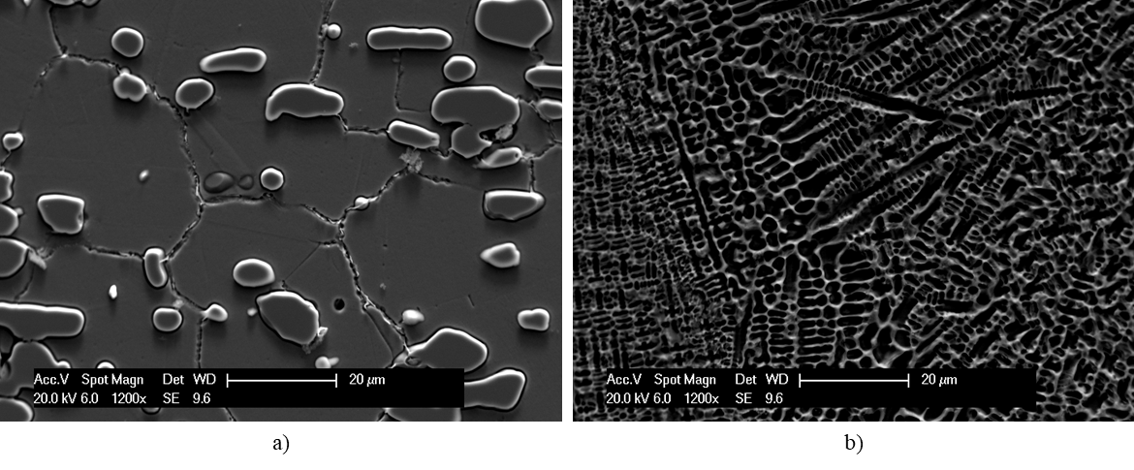

Figure 1.(Heading 2, 11 Font size, bold, initial letter capitalized). If figures have more than one part, each part should be labeled (a), (b), etc.

All of the figure and table should be centered. Figures and images should be numbered together (Figure 1) and figure title should be placed under the figure. The tableshould also be numbered (Table 1) and the table header should be placed at the top of the table. Table, image and figure headers should be written with upper case initial letters, bold and should be centered.

Table 1. Table headerlabels the caption, should be bold and initial letter capitalized. Center this text above the Table. Tables should have top and bottom rules, and a rule separating the column heads from the rest of the table.

Condition | Non-melted region | Top of Coating
Coated | 231±10 GPa | 188±42 GPa
Composite Coating | 211±52 GPa | 117±11 GPa
Initial | 209±13 GPa | -

3.1 Inserting Mathematical Equations (Heading 2, 11 Font size, bold, initial letters capitalized)

Equations should be placed in the left side with equation numbers on the right hand-side. You can either:

- Copy, paste and edit the sample equation provided (recommended ), or
- Manually insert an equation and equation number.

(1)

If you prefer to manually insert and number equations:
- Create a blank paragraph by pressing [ENTER].
- Insert your equation using InsertObjectMicrosoft Equation.
Be sure that the symbols in your equation have been defined before the equation appears or immediately following. Italicize symbols (T might refer to temperature, but T is the unit tesla).Punctuate equations when they are part of a sentence, as in

(2)

3.2 Units (Heading 2, 11 Font size, bold, initial letters capitalized)

Use SI as primary units. UCS units may be used as secondary units (in parentheses).

3.3 Abbreviations and Acronyms(Heading 2, 11 Font size, bold, initial letters capitalized)

Define abbreviations and acronyms the first time they are used in the text, even if they have been defined in the abstract. Do not use abbreviations in the title unless they are unavoidable.

4. CONCLUSIONS(HEADING 1,11 Font Size, bold, all caps)

Conclusions should include the most important findings inferred from the results, andthe future works and recommendations (3-4 lines).Although a conclusion may review the main points of the paper, do not replicate the abstract as the conclusion. A conclusion might elaborate on the importance of the work or suggest applications and extensions.

ACKNOWLEDGMENT(HEADING 1, 11 Font Size, bold, all caps)

Sponsor and financial support acknowledgments are placed here. Use the singular heading even if you have many acknowledgments.

REFERENCES(HEADING 1,11 Font Size, bold, all caps)
The reference section will follow the “Acknowledgment” section.References should be listed in alphabetical order and presented in a format according to APA6th Style. For more information, please visit: https://www.apastyle.org/index

Chua, C.K., Leong, K.F. (2017).3D Printing and Additive Manufacturing: Principles and Applications.World Scientific publishing Co, Liquid-Based Additive Manufacturing Systems (pp. 83-81). Danvers, USA.
Davids, D.L. (1998). Recovery effects in binary aluminum alloys. Ph.D. thesis, Harvard University.
Onuike, B., Bandyopadhyay, A. (2018). Additive Manufacturing of Inconel 718-Ti6Al4V bimetallic structures. Additive Manufacturing, 22, 844-851. https://doi.org/10.1016/j.addma.2018.06.025
Standard Test Method for Tension Testing of Metallic Materials. (2016). Retrieved from https://www.astm.org/Standards/E8
Stucker, B., Rosen, D.W. (2010). Additive Manufacturing Technologies.
Zelinski, P. (2019). What Is the Role for Additive Manufacturing in Aircraft Structural Components? Retrieved from https://www.additivemanufacturing.media

FINAL KEY POINTS

Here are the main points you need to follow:

- Write and prepare your article using this template
- Use and send your paper in M.S. Word File
- Please do not change the margins of this template.
- Prepare and format references using the examples above.
- Use clear, legible graphics and diagrams.
- Do not place copyrighted material without permission in article.
- Avoidfiles with large sizes (10 MB maximum, ideally).

We kindly invite you to visit our online platform when further information is needed. You can find the link below for assistance.
https://2020.amcturkey.org/

